LAB REPORT – 1
EXPERIMENT - 1
Familiarisation with Digital Test Kit and Binary Logic Levels

Name:Basireddy Khyathi Sri
Roll Number: 2023102065
Group Number: 6

Objective : 1) To get familiarized with the features of the Digital Test Kit
2) Using the Test Kit to understand the implications of binary logic
levels

Electronic components required : A breadboard, a power supply, a hex inverter(a 14 pin NOT gate assembly), a LED bulb,a resistor, a switch and connecting wires of different colors.

Reference Circuit :
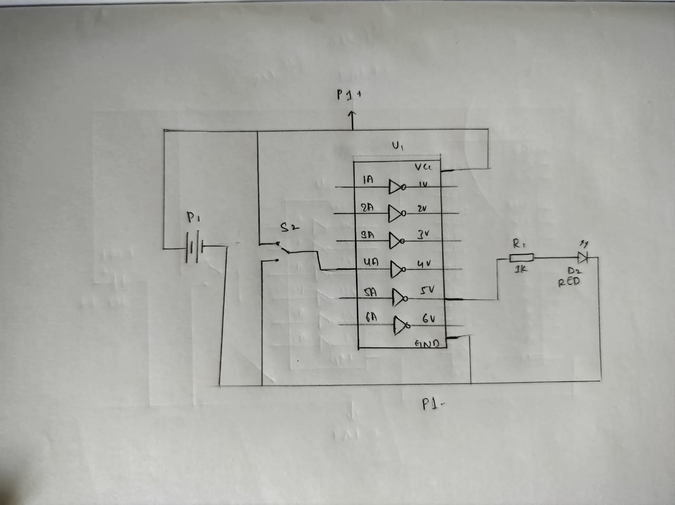

Procedure : 1)First on the breadboard, place the hex inverter or the ICE is
connected, one of the gate is then connected to the input and
output of the LED bulb.
2)Power is supplied to the ICE via the power supply through
connecting wires.
3)One of the gate is then connected to the VCC and one of the 14 pins
is connected to the ground(GND).
4)The Clock control switch is put in the FAST position. The VCC supply
is switched on.

Observation : 1) As we are using the NOT gate, the output is reversed as expected.
2)When the switch is turned on, the LED does not glow, but when it
is switched off the LED glows.

Conclusion : 1) NOT gates are simply inverters. They simply invert the input logic
for the output.
2) HIGH implies LOW and vice versa.

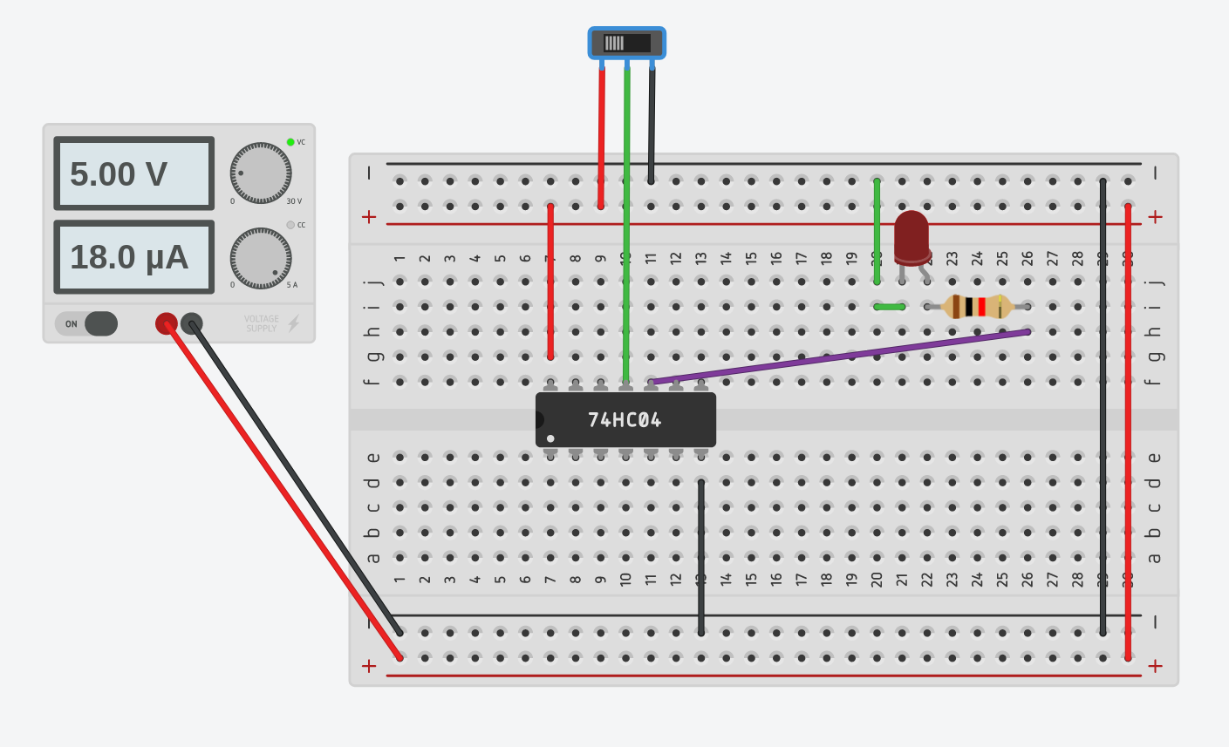

Link to the TinkerCad Simulation :
https://www.tinkercad.com/things/9YO9GvC6YRj-lab-simulation-1a/editel?sharecode=RKzI3Wqv4Si4G9JEclimHgdoCPI8niwQID_ovL5yTJA

EXPERIMENT - 2

Name:Basireddy Khyathi Sri
Roll Number: 2023102065
Group Number: 6

OBJECTIVE:
This experiment deals with micro controllers. This is to write a compile a C code
ATMega328P in Arduino ISP. This file connected to the microcontroller, run the
program and to observe the output. This experiments aim is to print “Hello World” on the serial monitor if the output of the NOT gate is 1 and nothing or “Bye World” if the NOT gate output is zero.

ELECTRONIC COMPONENTS REQUIRED:
1) Arduino ISP, digital kit
2) Slide switch
3) Connecting wires
4) Cable for connecting laptop to the Arduino
5) Battery
6) laptop
7) Hex inverter

REFERENCE CIRCUIT:
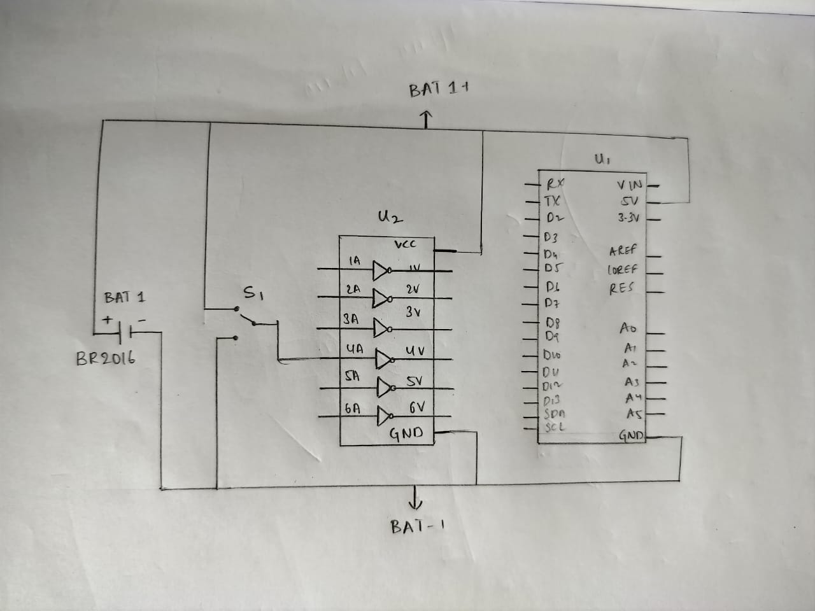

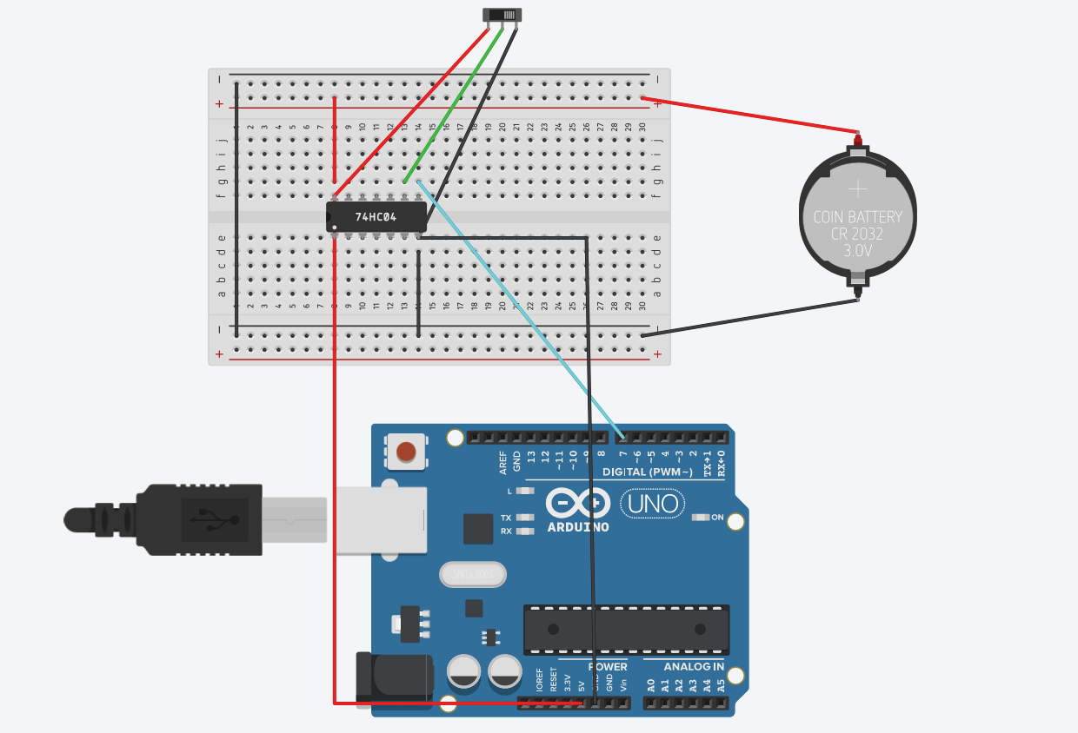
TinkerCad Screenshot

PROCEDURE:
1) First, we need to connect the 5V terminal to VCC plug in point and GND
terminal to the breadboard using wires, for that we should have same base
voltage.
2)Therefore, we must not connect it to two different terminals of GND
as the voltage may slightly vary.
3) Then connect the output of the not gate to the input of the Arduino (I
have chosen 7th terminal.)
4) Connect the respected device in which you want the output with a cable
to the Arduino ISP.
5) Install Arduino IDE1 on Linux . To write code for “Hello World” and print it in a loop.
6) Then compile the code and check for errors.
7) In ‘Tools section’ select the ‘Board type’ (Arduino Uno) and the
corresponding PORT().
8) Now send the code onto the micro controller.
9) Check for the output on the serial monitor

CODE:
- void setup()
- {
- Serial.begin(9600);
- pinMode(7, INPUT);
- }

- void loop()
- {
- int NOT_OUTPUT = digitalRead(7);
- if(digitalRead(7) ==1)
- {
- Serial.print("Hello World!\n");
- }

- else
- {
- Serial.print("Bye World!\n");
- }
- delay(1000);
- }

OBSERVATIONS:
When we have given the input as 1, serial monitor printed “Bye World” nothing because NOT gate converts 1 to 0 as the output. When we give input as 0, then we
got “Hello World “ printed in a loop with a delay of 1000 milli seconds on
the serial monitor.

CONCLUSION:
The experiment helped me very much to know about these all instruments and I got to know all these things functions and it very interesting and fun doing this activity.

The Arduino Uno can be used along with different hardware components and the
Arduino IDE to integrate hardware and software.

Link to TinkerCad Simulation:
https://www.tinkercad.com/things/fZdkSrzjnQi-lab-simulation-1b-main/editel?sharecode=vKHz-Olo38KyepPEeKT6m7HyL1TXMIF7n8PXfnQ0ksg

